Service Bus – Queue
First Create Namespace in Service Bus of Azure
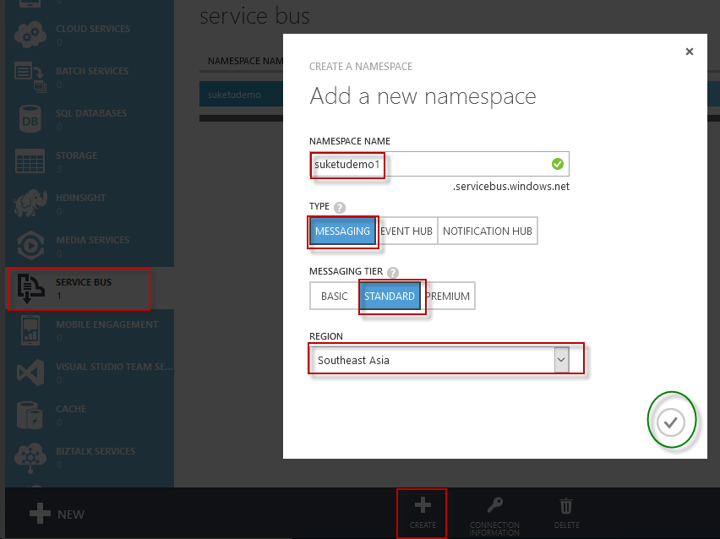
Service Bus is active
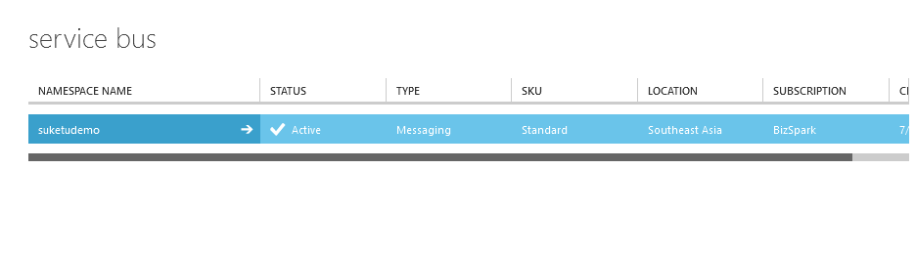
Now Create Queues for Example of Broker Message Sender and Receiver for Service Bus Queue
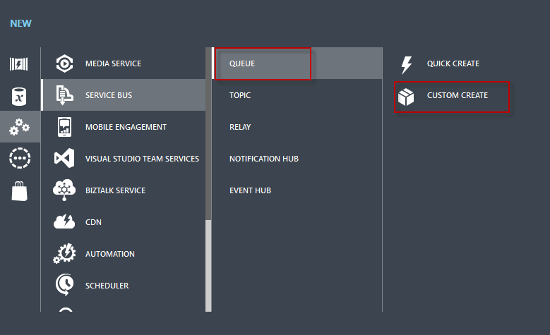
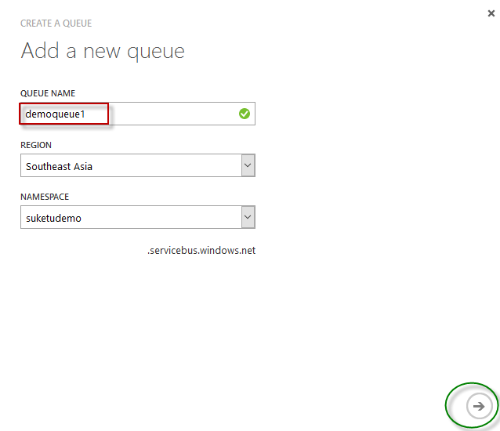
Currently in Queue Length No Message so Zero
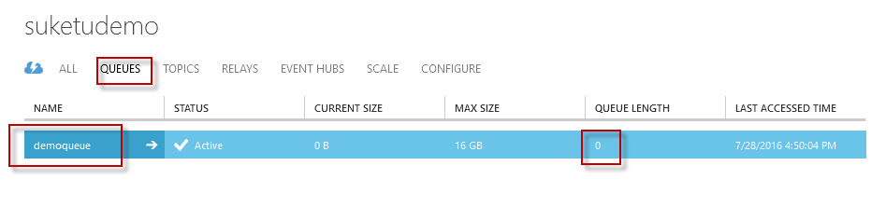
For Connection String of Service Bus Namespace
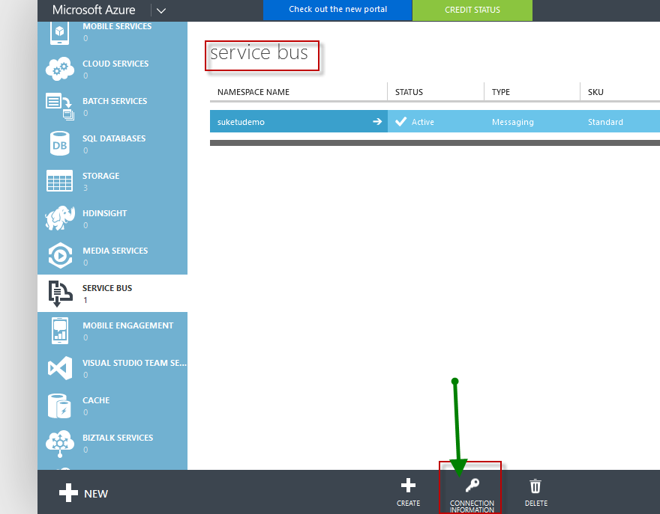
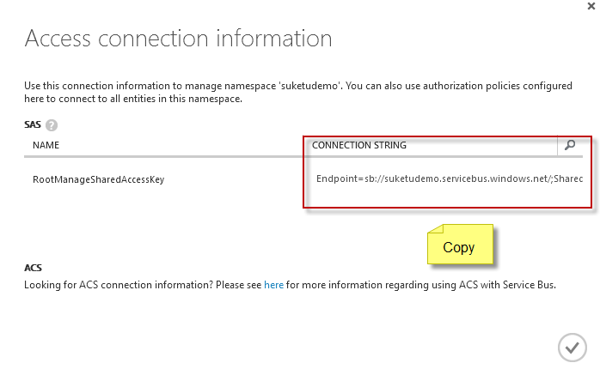

Now in Visual Studio Add -> New Project -> Console Application
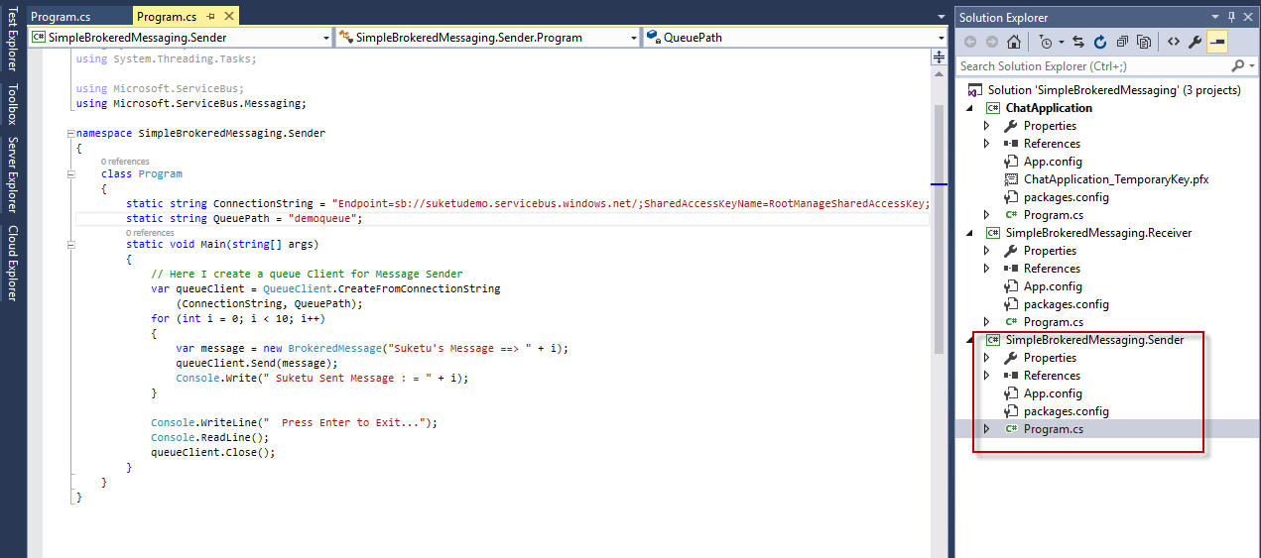
Add Code on Program.CS file

using System;
using System.Collections.Generic;
using System.Linq;
using System.Text;
using System.Threading.Tasks;

using Microsoft.ServiceBus;
using Microsoft.ServiceBus.Messaging;

namespace SimpleBrokeredMessaging.Sender
{
class Program
{
static string ConnectionString = "Endpoint=sb://suketudemo.servicebus.windows.net/;SharedAccessKeyName=RootManageSharedAccessKey;SharedAccessKey=/nwKJH0ya/+lcAMCWsw0RJ6kONE+x5CQ0JsAQVaiT+Q=";
static string QueuePath = "demoqueue";
static void Main(string[] args)
{
// Here I create a queue Client for Message Sender
var queueClient = QueueClient.CreateFromConnectionString
(ConnectionString, QueuePath);
for (int i = 0; i < 10; i++)
{
var message = new BrokeredMessage("Suketu's Message ==> " + i);
queueClient.Send(message);
Console.Write(" Suketu Sent Message : = " + i);
}

Console.WriteLine(" Press Enter to Exit...");
Console.ReadLine();
queueClient.Close();
}
}
}

Add Windows Azure Service Bus from NuGet Package Manager
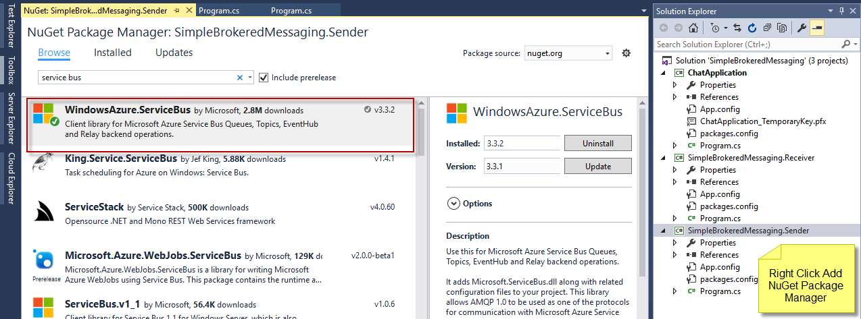
Run the Sender Console Application to Add 10 Messages in Service Bus Queue
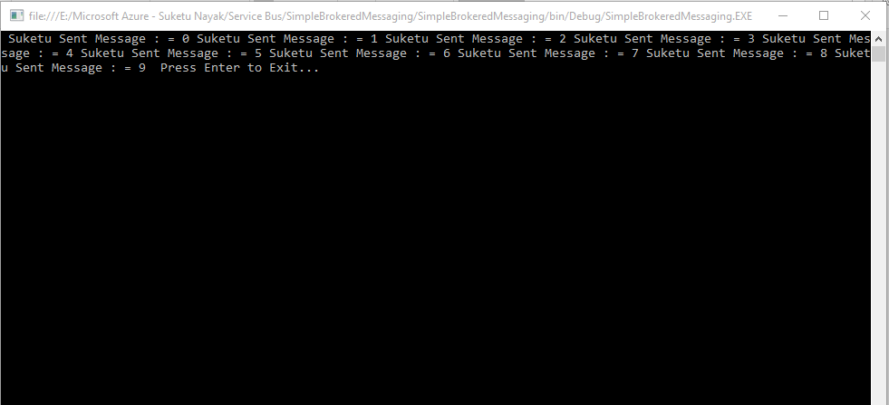
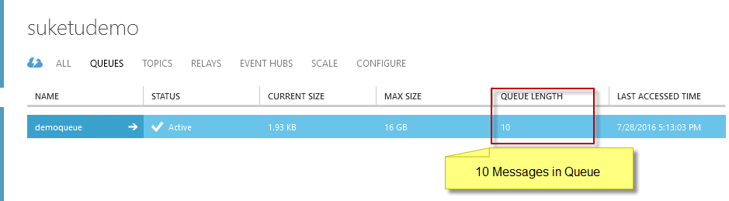
Now Add one more console application in same explorer for receiver
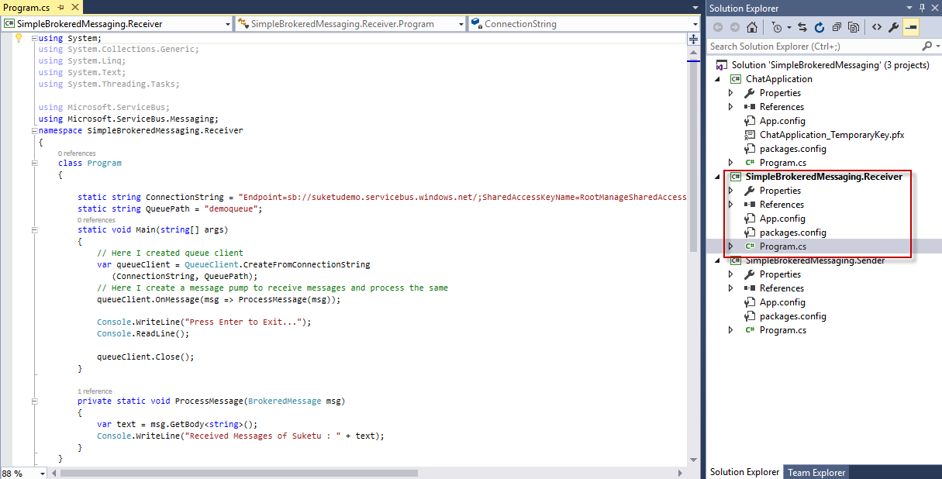
Add code in Program.CS file
using System;
using System.Collections.Generic;
using System.Linq;
using System.Text;
using System.Threading.Tasks;

using Microsoft.ServiceBus;
using Microsoft.ServiceBus.Messaging;
namespace SimpleBrokeredMessaging.Receiver
{
class Program
{

static string ConnectionString = "Endpoint=sb://suketudemo.servicebus.windows.net/;SharedAccessKeyName=RootManageSharedAccessKey;SharedAccessKey=/nwKJH0ya/+lcAMCWsw0RJ6kONE+x5CQ0JsAQVaiT+Q=";
static string QueuePath = "demoqueue";
static void Main(string[] args)
{
// Here I created queue client
var queueClient = QueueClient.CreateFromConnectionString
(ConnectionString, QueuePath);
// Here I create a message pump to receive messages and process the same
queueClient.OnMessage(msg => ProcessMessage(msg));

Console.WriteLine("Press Enter to Exit...");
Console.ReadLine();

queueClient.Close();
}

private static void ProcessMessage(BrokeredMessage msg)
{
var text = msg.GetBody<string>();
Console.WriteLine("Received Messages of Suketu : " + text);
}
}
}
Again for this Receiver App Add Windows Azure Service Bus from NuGet Package Manager
Run the Program
